Experiment-9

Views

1.create a table student attributes stdno,name,dept

2.Display



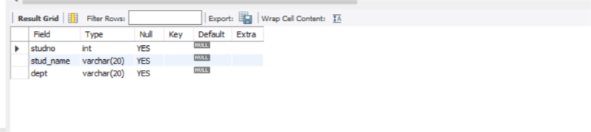

3.create view and select



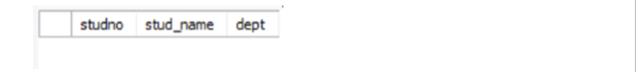

4.Insert values



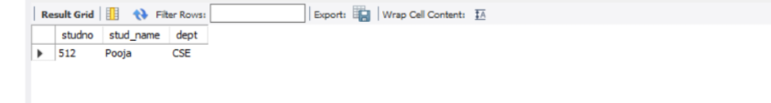

5.create view with check option

Insert values and alter tables

